**‘AccessBank DBA Internship Program’**

**Project 7: Checking database consistency**

Imagine you received an email alert (well-known error 825):

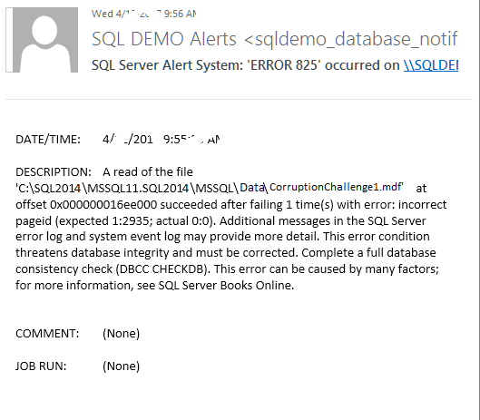

You immediately go to your SQL Server and run DBCC CHECKDB for the CorruptionChallenge1 database to make sure whether corruption exists or not. Please do the following tasks:

1. Fill up the following table:

|  |  |  |
| --- | --- | --- |
| Database Name | Corrupted?  Yes/No | Errors |
| **CorruptionChallenge1** | **YES** | **Msg 8944, Level 16, State 13, Line 1**  Table error: Object ID 245575913, index ID 1, partition ID 72057594040614912, alloc unit ID 72057594045857792 (type In-row data), page (1:280), row 3. Test (ColumnOffsets <= (nextRec - pRec)) failed. Values are 3139 and 288.  **Msg 8944, Level 16, State 13, Line 1**  Table error: Object ID 245575913, index ID 1, partition ID 72057594040614912, alloc unit ID 72057594045857792 (type In-row data), page (1:280), row 3. Test (ColumnOffsets <= (nextRec - pRec)) failed. Values are 3139 and 288.  **Msg 8928, Level 16, State 1, Line 1**  Object ID 245575913, index ID 1, partition ID 72057594040614912, alloc unit ID 72057594045857792 (type In-row data): Page (1:280) could not be processed. See other errors for details.  **Msg 8976, Level 16, State 1, Line 1**  Table error: Object ID 245575913, index ID 1, partition ID 72057594040614912, alloc unit ID 72057594045857792 (type In-row data). Page (1:280) was not seen in the scan although its parent (1:281) and previous (1:246) refer to it. |

1. Share your error logs after running DBCC CHECKDB command (hint: export error log to a file and then copy-paste here those logs):

**Msg 8944, Level 16, State 13, Line 1**

Table error: Object ID 245575913, index ID 1, partition ID 72057594040614912, alloc unit ID 72057594045857792 (type In-row data), page (1:280), row 3. Test (ColumnOffsets <= (nextRec - pRec)) failed. Values are 3139 and 288.

**Msg 8944, Level 16, State 13, Line 1**

Table error: Object ID 245575913, index ID 1, partition ID 72057594040614912, alloc unit ID 72057594045857792 (type In-row data), page (1:280), row 3. Test (ColumnOffsets <= (nextRec - pRec)) failed. Values are 3139 and 288.

**Msg 8928, Level 16, State 1, Line 1**

Object ID 245575913, index ID 1, partition ID 72057594040614912, alloc unit ID 72057594045857792 (type In-row data): Page (1:280) could not be processed. See other errors for details.

**Msg 8976, Level 16, State 1, Line 1**

Table error: Object ID 245575913, index ID 1, partition ID 72057594040614912, alloc unit ID 72057594045857792 (type In-row data). Page (1:280) was not seen in the scan although its parent (1:281) and previous (1:246) refer to it. Check any previous errors.

**Firstly, I restored CorruptionChallenge1 database by using CorruptionChallenge1.bak file:**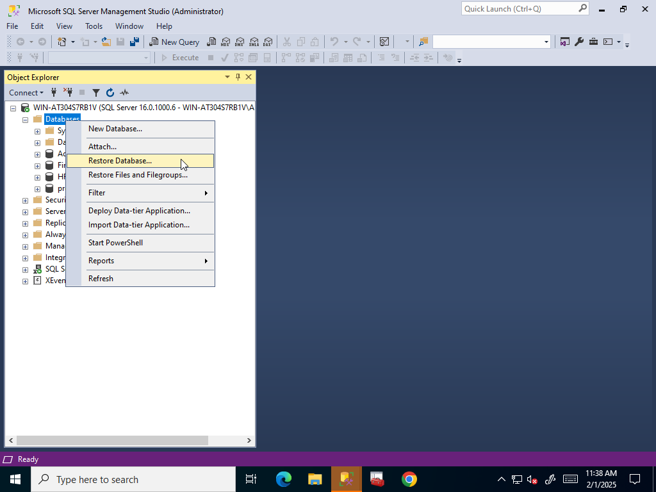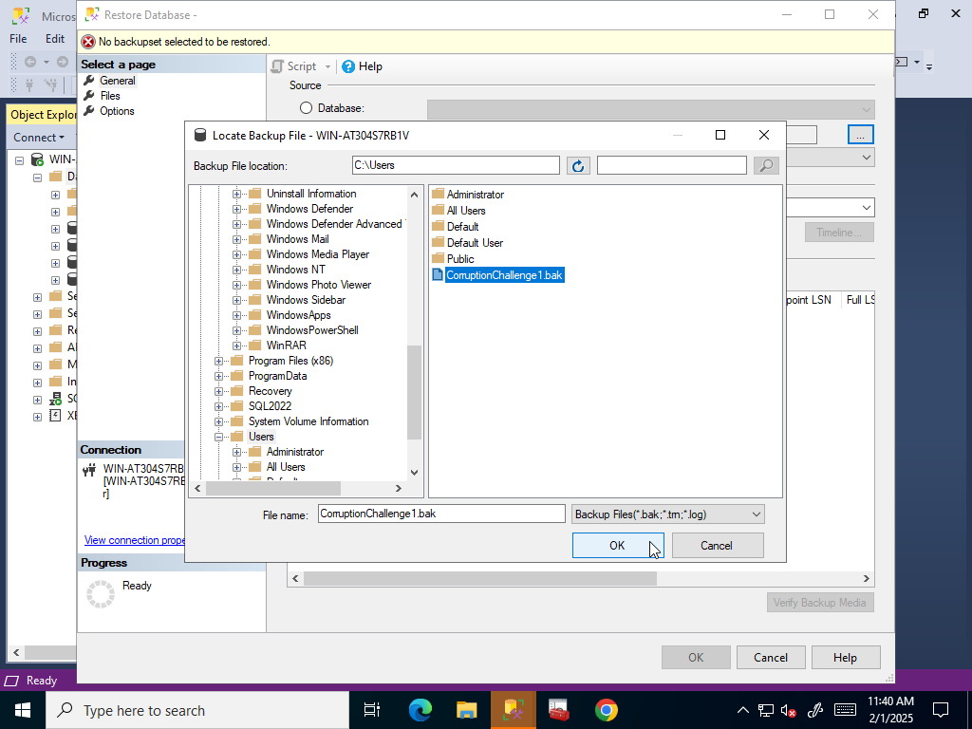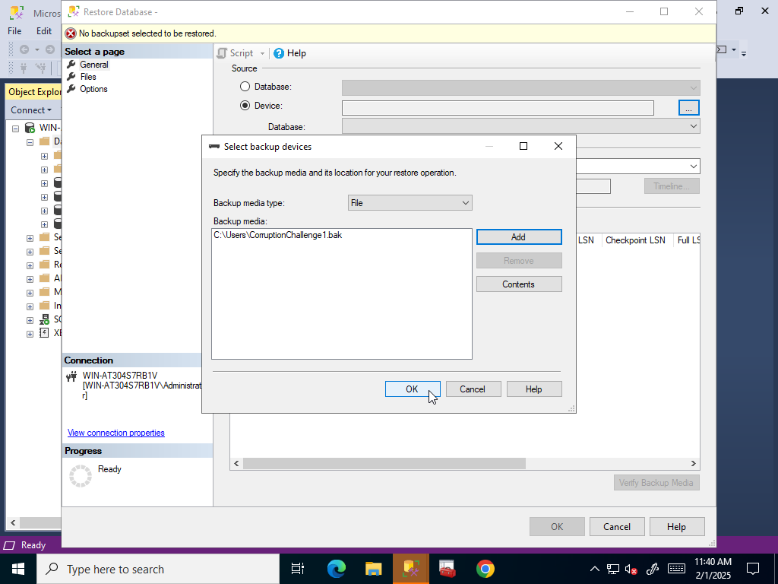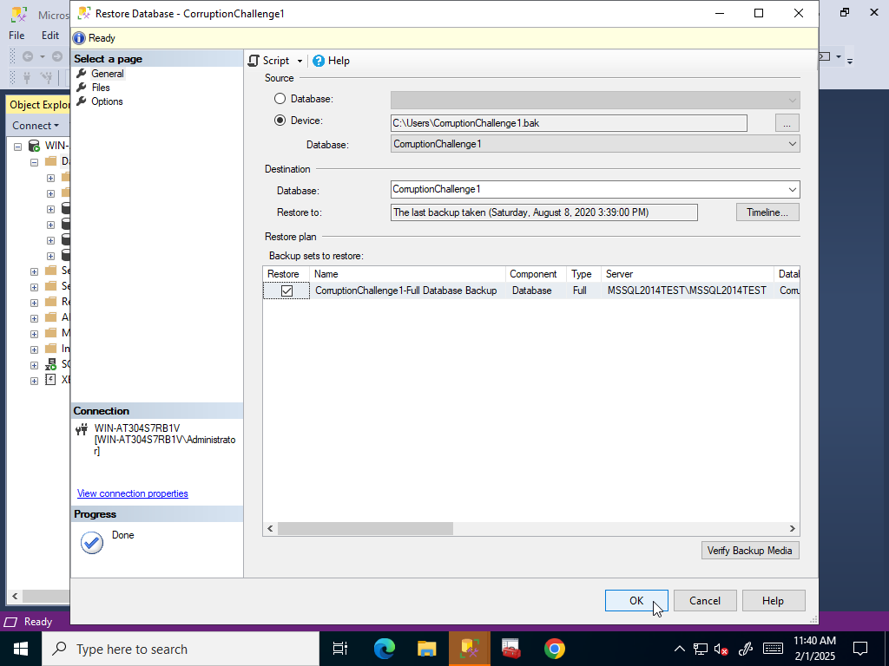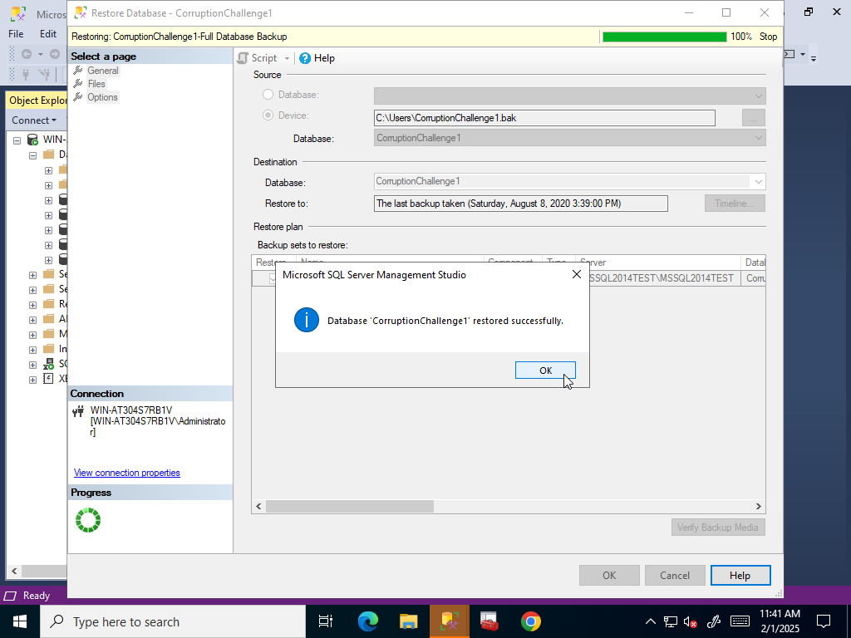

**After restoring, I executed following script to see whether it’s corrupted or not and it’s corrupted as you can see:**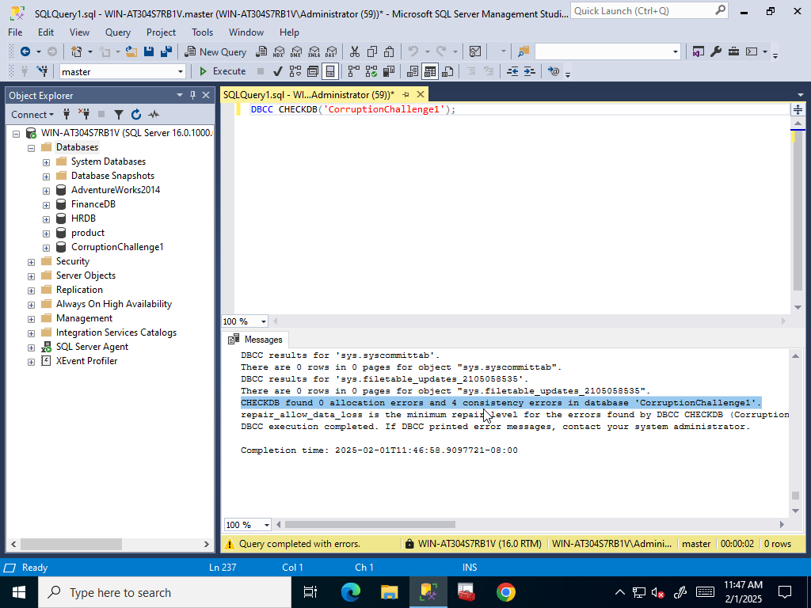

**Then I used Query -> Results To -> Results to File to export that query’s results to a .rpt file:**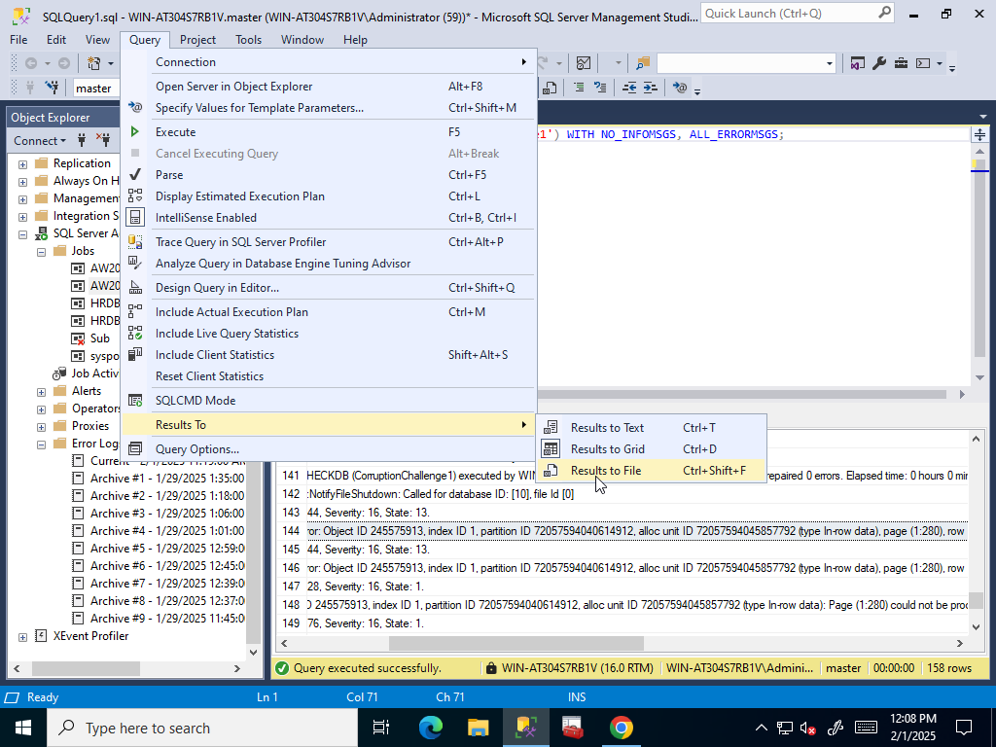

**After executing T-SQL script we see that it says to save results to new file and name and locate it whatever we want:**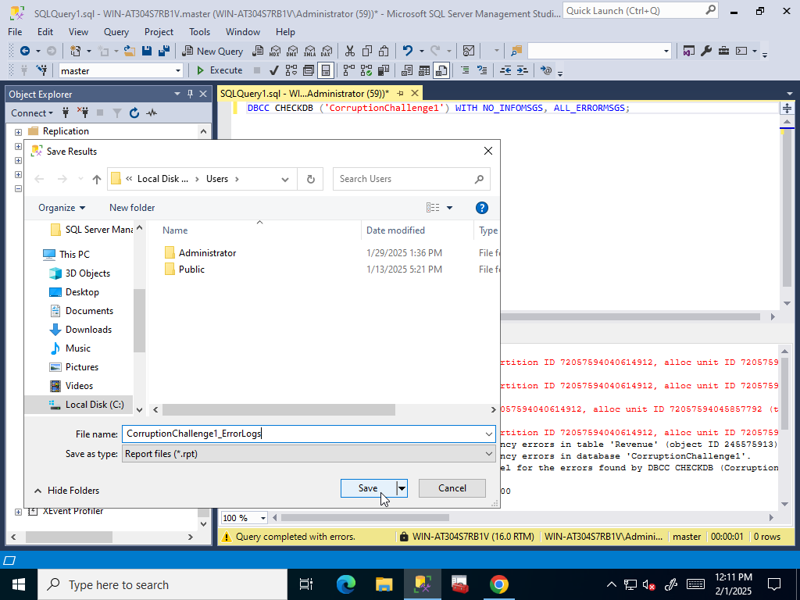

**Then I went to that file and after clicking I copied errors to fill the blank:**